Project 2-A: NAT

CS 436

Shay Ramirez

Kenneth Campbell

# Files Included:

1. nat_table.py
2. scapy_tcp.py

# How to use

1. Check that python is installed and up to date on your computer:

Run the following command to check if / what version of python is installed:

Python3 –version

1. Switch over to the directory containing the files:

nat_table.py

scapy_tcp.py

1. You should use sudo command to run this program as root privilege is required for packet receiving.
2. Type in the following command to run the scapy_tcp.py file:

sudo python3 scapy_tcp.py

Expected Output:

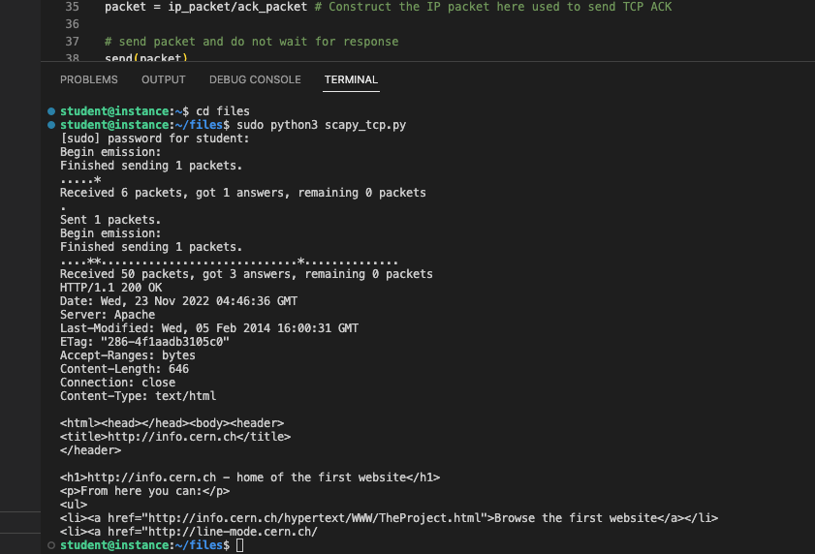

(If scapy_tcp.py runs successfully, expect to see the above results)

1. Type in the following command to run the nat_table.py file:

sudo python3 nat_table.py

Expected Output:

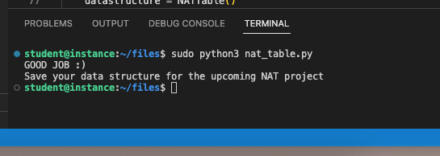

(If nat_table.py runs successfully, expect to see the above results)

# Explanation

1. nat_table.py

Purpose:

To serve as a NAT Table, which uses a translation table to manage the mapping between a (private IPv4 address, TCP port) and a (public IPv4 address, TCP port). This map / Nat Table will be accessed every time you receive a packet (from a client destined to a server, and also when a packet is received from a server, destined for a client).

Imports

* + 1. IMPORT random

Purpose

Allows use of random number generator / utility

* + 1. FROM typing IMPORT Tuple

Purpose

Allows use of the Tuple data structure

Classes:

* + 1. NATTable

Defines the class used for constructing and interacting with the NAT Table Object. As well as providing a tester class to ensure the code’s functionality.

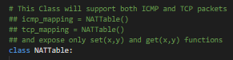

Functions:

1. __init__

Purpose:

This is the class constructor (function) that is responsible for initializing / declaring the data structures that will house the information provided to and by the class.

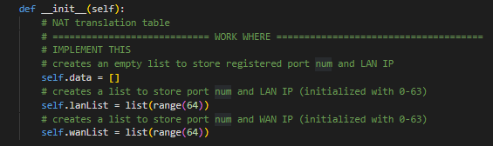

1. test_datastructure

Purpose:

This is a test function that simulates practical use of the NATTable class, ensuring that the code operates as expected.

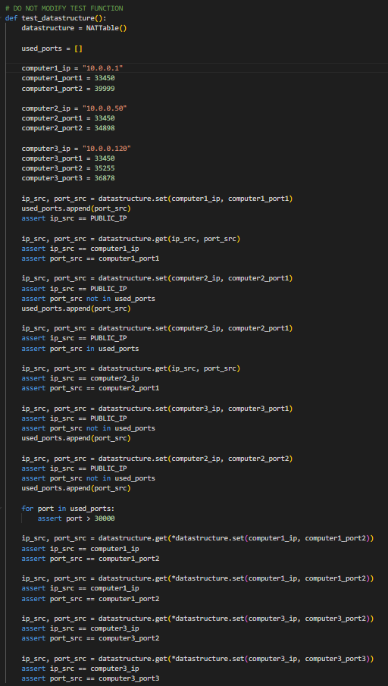

1. _random_id

Purpose:

This function is responsible for generating a random number that falls between the valid ranges of potential port numbers (falling between 30000, 65535, i.e. all port numbers available, that are greater than 30000).



1. Get

Purpose:

This function will retrieve the corresponding IP and port number that is mapped to a given source IP and port number.

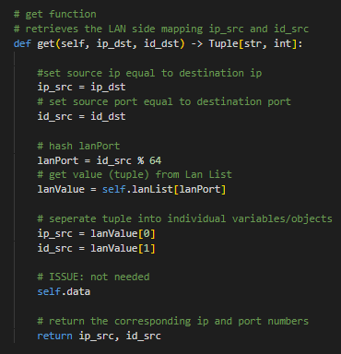

1. Set

Purpose:

This function establishes a new random port for each new connection to use when interfacing with servers/clients that are outside/inside your current network. This function will also check if the connection has already been mapped, if the connection already exists, the respective IP and port number will be returned; otherwise, implies that the connection does not exist, and thus, this function will establish the new connection and add it to the NAT table.

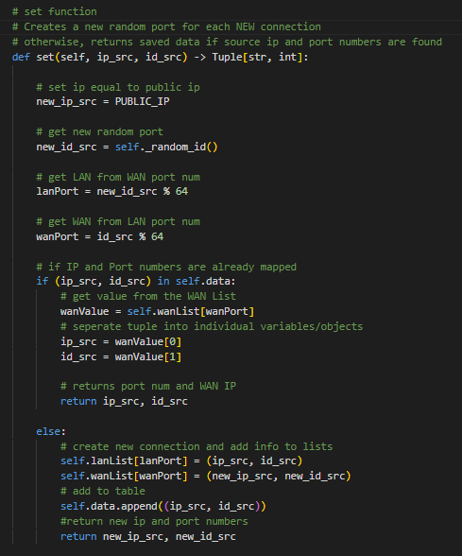

1. scapy_tcp.py

Purpose:

To use packet encapsulation and Scapy knowledge to construct an IP packet containing an HTTP GET request to this host info.cern.ch.

